# Technical instructions

## Graphics

### Photo to vector grahic conversion

Open photo in GIMP (as jpg)

Color tab -> threshold to sharpen

Filter tab -> blur ->gausian blur to smooth shapeness

Color tab -> threshold color again to sharpen

Export png (from GIMP)

Then drag or import into Inkscape

In Inkscape

Path tab -> trace bitmap. This makes additional svg image on top of the png image. Move one to see which is which, delete the non-bitmap image.

## GitHub / GitKraken

### Staging confirming changes

Click work in progress to list changes

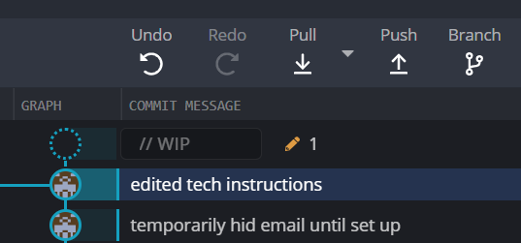



Check changes and “stage” individually or in groups

Maximise/minimise boxes of lists of changes and staged changes for easy viewing.

Writ comments for each set in the “staged” box, then stage all

Then “push” icon at top

### Using branches

Tree tab at top creates new branch

Name new branch

Swap between branches with “main” tab. Whichever is selected is the one that appears in the code programme.

Can use “control Z” to revert to previous code even after saving.

Main branch should always be live/publishable.

When satisfied with changes in branch, drag branch onto main branch, select “merge into main”. Branch then appears as inactive and linking back into main trunk

## Updating live website

Run Matt’s code in bat file in Jenny’s home drive H:\website versions\WebsiteUpdateScriptChanges have to already be committed and pushed and in main branch of Git

DON’T NEED TO DO THIS